**ShopNest Store Power BI Capstone**

ShopNest stands as the leading department store in the e-commerce marketplaces in Portugal. Serving as a seamless link, it connects small businesses from various regions in Portugal to channels, streamlining the process with a single point of contact. Through the ShopNest Store, these merchants can showcase and sell their products, with the added convenience of direct shipment to customers facilitated by ShopNest logistics partners.

1. **Top Categories by Total Price:**
   1. Identify and visually represent the top 10 product categories by total sales.

**Key insights and findings: -**

* ﻿At 14,41,248.07, beleza_saude had the highest Sum of Total_Sales and was 146.70% higher than ferramentas_jardim, which had the lowest Sum of Total_Sales at 5,84,219.21.
* ﻿beleza_saude accounted for 14.60% of Sum of Total_Sales.
* ﻿Across all 10 products.product_category_name, Sum of Total_Sales ranged from 5,84,219.21 to 14,41,248.07.

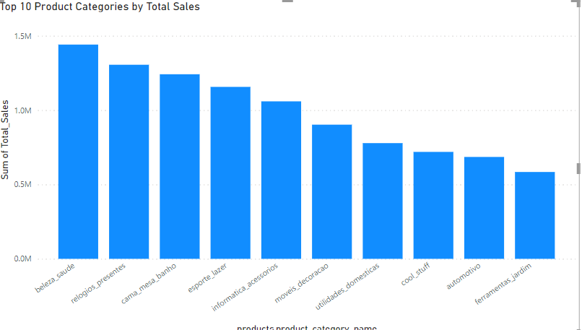

1. **Delayed Orders Analysis:**
   1. Determine the number of delayed orders in each category. An order is considered delayed if the actual delivery date is later than the estimated delivery date.

**Key insights and findings: -**

* ﻿﻿ ﻿﻿Delayed Orders by Category was highest for cama_mesa_banho at 770, followed by beleza_saude and moveis_decoracao.﻿﻿ ﻿
* cama_mesa_banho accounted for 10.60% of Delayed Orders by Category.
* ﻿Across all 67 product_category_name, Delayed Orders by Category ranged from 1 to 770.

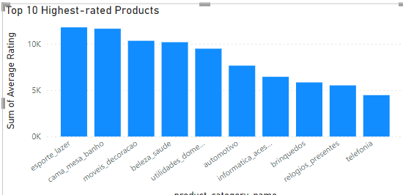

1. **Monthly Comparison of Delayed and On-Time Orders:**
   1. Create a dynamic visual that compares the number of delayed orders to the number of orders received earlier for each month. Utilize the drillthrough cross-report feature to provide a detailed analysis of late and on-time deliveries.

**Key insights and findings: -**

* ﻿At 1444, March had the highest DelayedOrders and was 769.88% higher than June, which had the lowest DelayedOrders at 166.
* OnTimeOrders and DelayedOrders diverged the most when the order_purchase_timestamp - Copy was August, when OnTimeOrders were 9514 higher than DelayedOrders.
* ﻿Across all 12 order_purchase_timestamp - Copy, DelayedOrders ranged from 166 to 1444 and OnTimeOrders ranged from 3968 to 10029.

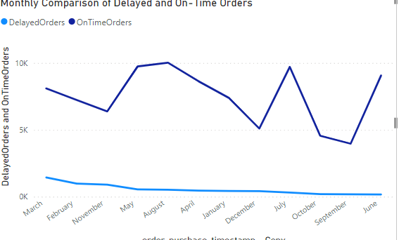

1. **Payment Method Analysis:**
   1. Analyze the most frequently used payment methods by customers using a visually appealing representation, such as a pie chart or other suitable visuals.

**Key insights and findings: -**

* Most of the customers are using credit cards (73%) then followed by boleto(19%), then voucher, less people are using debit cards.

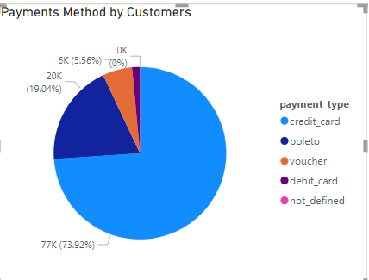

1. **Product Rating Analysis:**
   1. Determine the top 10 highest-rated products and the bottom 10 lowest-rated products using a bar or column chart.

**Key insights and findings: -**

**Top 10 Products and Bottom 10 Products: -**

* At 11,784.12, esporte_lazer had the highest Sum of Average Rating and was 163.84% higher than telefonia, which had the lowest Sum of Average Rating at 4,466.43.﻿
* esporte_lazer accounted for 14.14% of Sum of Average Rating.
* ﻿Across all 10 product_category_name, Sum of Average Rating ranged from 4,466.43 to 11,784.12.

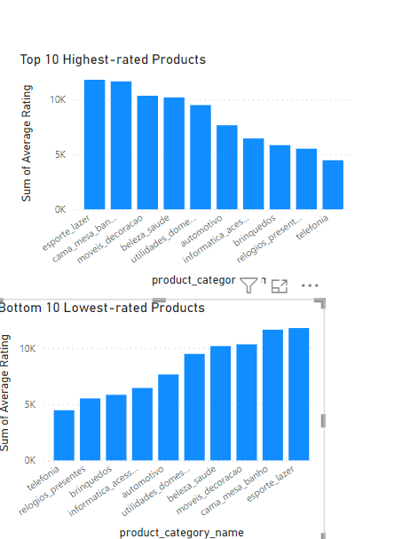

1. **State-wise Sales Analysis:**
   1. Identify and visually represent states with high and low sales, providing a clear understanding of regional sales performance.

**Key insights and findings: -**

* ﻿Total Count of State Sales Category was higher for High Sales (14) than Low Sales (13).

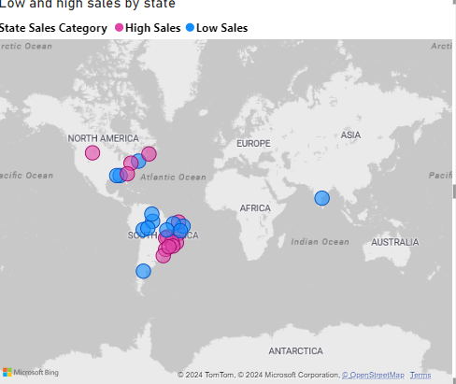

1. **Seasonal Sales Patterns:**
   1. Investigate and visualize any seasonal patterns(Quarterly) or trends in sales data over the course of the year.

**Key insights and findings: -**

* 2018 had the highest total TotalSales at 73,86,050.80, followed by 2017 at 61,55,806.98 and 2016 at 49,785.92.﻿
* ﻿2 in Year 2018 made up 21.03% of TotalSales.
* 2018 had the highest average TotalSales at 24,62,016.93, followed by 2017 at 15,38,951.74 and 2016 at 24,892.96

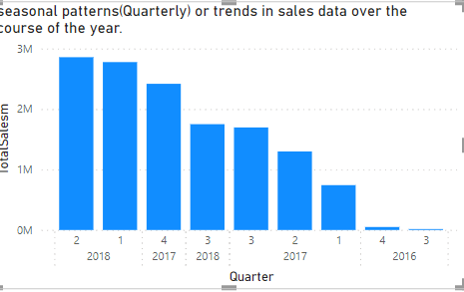

1. **Revenue Analysis:**
   1. Determine the total revenue generated by ShopNest Store  and analyze how it changes over time(Yearly). Represent this information through suitable visuals to highlight trends and patterns.

**Key insights and findings: -**

* At 86,43,697.60, 2018 had the highest Sum of TotalRevenue and was 15,015.80% higher than 2016, which had the lowest Sum of TotalRevenue at 57,183.21.
* 2018 had the highest Sum of TotalRevenue at 86,43,697.60, followed by 2017 at 71,42,672.43 and 2016 at 57,183.21.
* 2018 accounted for 54.56% of Sum of TotalRevenue.
* 2017 had 71,42,672.43 Sum of TotalRevenue, 2018 had 86,43,697.60, and 2016 had 57,183.21.

